Pig Dinner 2004
The 29th Annual Norris Pig Dinner is about a week away. With that in mind, here is a rundown of the necessary information:
- This year’s Annual Pig Dinner has been moved from the UCR Commons Banquet

Facility to The Barn and will be held on Saturday, May 15th, 2004. The schedule for

the dinner is as follows:

Reception: 6:00p.m
Dinner: 7:00p.m.

Pig Roast @ the House: 9:00p.m.

Program for Pig Dinner:
Master of Ceremonies
Eric Carter ‘01

Exile’s Toast
Dave Wilkerson ‘80

Keynote Address
Bill Kramer (Gettysburg ’78)
Archon Councilor

Entrees
Duet of London Broil and Chicken Breast Dijonnaise

For those who RSVP’d before the dinner, the price is $60, otherwise its $70 at
the door (This price also includes hosted bar). Lastly, for those who do not eat red meat or eat vegetarian please notify the Pig Dinner Chairman before so arrangements can be made to accommodate you.
- Parking for Pig Dinner will be in Parking Lot 4 (Please see attached maps). Signs will be posted at every entrance and on campus. The cost for parking will be $5.00. This fee is charged by Parking Services, we have no control over it.
- For those brothers who are coming in from out of town here is a list of hotels in the area:
The Courtyard Marriott (909) 784-8000 - 3400 Market Street
Mission Inn (909) 784-0300 - 3649 Mission Inn Ave
Dynasty Suites (909) 369-8200 - 3735 Iowa Ave
- Those still interested in playing golf on Saturday morning, contact Brother Eric Carter at 415-706-6725 or email him at ericmcarter@hotmail.com. This year's tournament will be held at Shandin Hills Country Club in San Bernardino (3380 Little Mountain Drive, San Bernardino, CA 92405 (909) 886-0669). Golf begins at 9:00am and is $60 per person. Price includes golf, cart, and lunch. There are several spaces open.

Maps
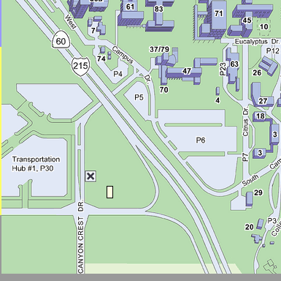



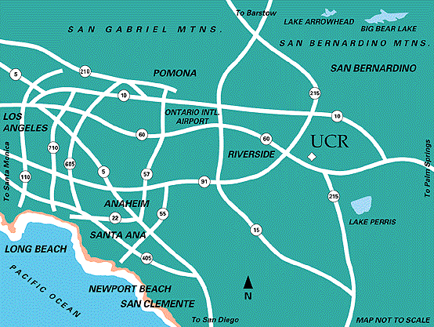
Inland Empire Traffic (real time)
TANN Inland Empire Map
From Los Angeles County
From the 91 freeway: Take the 91 freeway east to the 60 freeway east. Exit at University Avenue and turn left. Go to the second light and make a right onto Campus Drive.
From the 10 freeway: Take the 10 freeway east to Interstate 15 south and then to the 60 freeway east. Exit at University Avenue and turn left. Go to the second light and make a right onto Campus Drive.
From the 60 freeway: Take the 60 freeway east. Exit at University Avenue and turn left. Go to the second light and make a right onto Campus Drive.
From Orange County
Take the 91 freeway east to the 60 freeway east. Exit at University Avenue and turn left. Go to the second light and make a right onto Campus Drive.
From Ontario Airport
From the 10 freeway: Take the 10 freeway east, to the 15 south and then to the 60 east. Exit at University Avenue and turn left. Go to the second light and make a right onto Campus Drive.
From the 60 freeway: Take the 60 freeway east. Exit at University Avenue and turn left. Go to the second light and make a right onto Campus Drive.
From Palm Springs
Take the 10 freeway west to the junction with the 60 freeway and go west. Exit at University Avenue and turn left. Go to the first traffic signal and turn right onto Campus Drive.
From San Bernardino
Take the 215 freeway south to the junction with the 60 freeway and go east. Exit at University Avenue and turn left. Go to the second traffic signal and turn right onto Campus Drive.
From San Diego County
Take the 15 freeway north to the 215 north and then the 60 freeway west. Exit at University Avenue and turn left. Go to the first light and make a right on Campus Drive.

